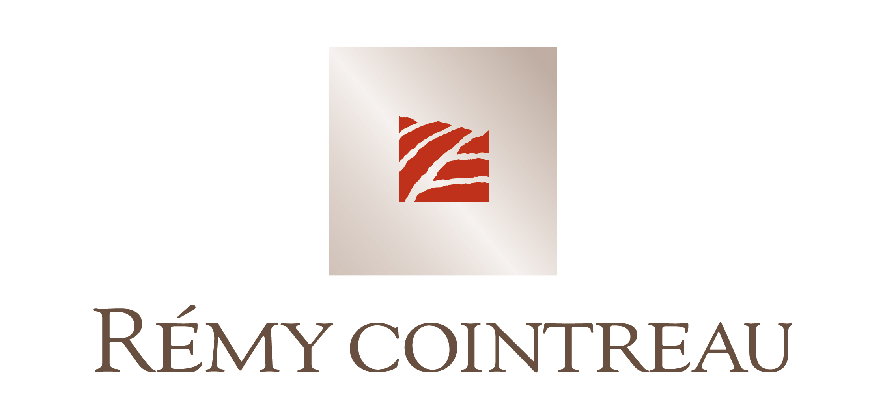

1 March 2005

Establishment of an Executive Committee

Since joining Rémy Cointreau in September 2004, Jean-Marie Laborde, Chief Executive Officer, has structured his Management team and established an Executive Committee, which he chairs. Within this framework, he will strengthen the team by creating three new executive management positions:

Director of Strategy and Development of Brands - Christian Liabastre - who joined the Group at the beginning of January 2005. Previously Marketing Director of Orangina and International Marketing Director of Hennessy cognac, he has been Chairman of Young & Rubicam, France, since 1997. Christian Liabastre will be responsible for the entire portfolio of Rémy Cointreau’s brands and will also oversee the Group’s cross-divisional marketing activities.

Director of Markets and Commercial Networks with responsibility for all the distribution networks of the Group, and also acting as a link to Maxxium. This position is currently being filled by Jean-Marie Laborde, Chairman of Maxxium and Rémy Amérique, while a suitable candidate is being sought.

Director of Operations - Damien Lafaurie - who joined the Group in 2002 as the manager responsible for implementing the supply chain project. Damien Lafaurie will be responsible for the Group’s production and logistics as well as purchasing and sustainable development activities.

In addition, the Executive Committee will comprise the following members:

Hervé Dumesny, Group Chief Financial Officer since May 2004,

Jean-François Boueil, Group Human Resources Director since February 2005. He was previously Group Corporate Affairs Director and Human Resources Director of the Champagne division, a role he will retain, and

Jim Chambers, Chief Executive of Rémy Amérique since 2003, based in New York.

This committee will have a highly operational role, focusing on performance, and concentrating on customer and consumer satisfaction.

Rémy Cointreau has ensured that through its dynamic management it is well positioned to meet the challenges of global competition whilst maximising its strategic and commercial positions.

Contact: Joëlle Jézéquel – 33 1 44 13 45 15

