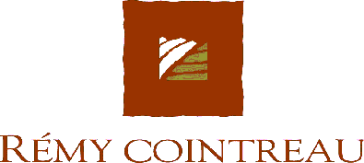

NOT FOR PUBLICATION OR DISTRIBUTION OR RELEASE IN THE UNITED STATES OF AMERICA, JAPAN OR CANADA.

26 March 2004

Disposal of Rémy Cointreau Shares

Rémy Cointreau announces the following:

- That it has partly unwound earlier than anticipated an Equity Swap set up with a credit institution on 28 October 2001.
- That Orpar, the controlling shareholder, also unwound earlier than anticipated an Equity Swap set up with a credit institution on 18 April 2001.

These transactions have led to a disposal of 2,561,223 shares representing 5.7% of the share capital of Rémy Cointreau.

The placing was effected exclusively with institutional investors on the international markets.

Crédit Agricole Indosuez-Crédit Lyonnais and Société Générale were sellers and joint bookrunners.

This additional disposal is part of the debt reduction programme set up by Rémy Cointreau Group.

This announcement is not for publication or distribution or release in the United States of America (including its territories and possessions, any State of the United States and the District of Columbia). This announcement does not constitute or form part of an offer to sell or solicitation of an offer to purchase or subscribe for securities in the United States or any other jurisdiction. The securities referred to herein have not been and will not be registered under the United States Securities Act of 1933, as amended, and may not be offered or sold in the United States or to or for the benefit of U.S. persons, absent registration or pursuant to an applicable exemption from the registration requirements of the Securities Act. No public offering of securities is being made in the United States.

