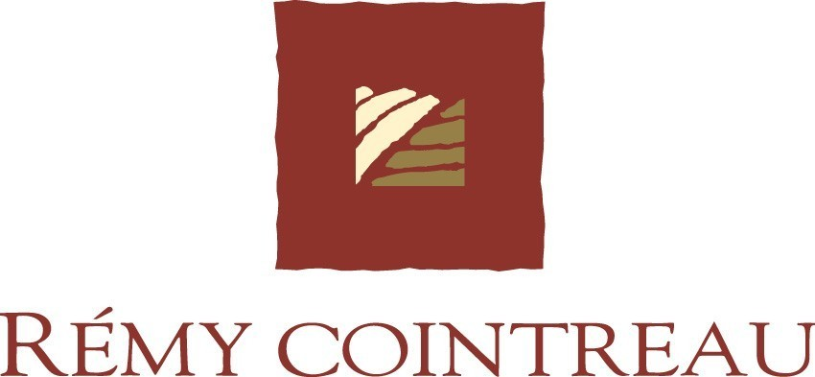

21 October 2004

CONSOLIDATED TURNOVER FOR THE SIX MONTHS
APRIL – SEPTEMBER 2004

Good growth by key brands in the first half of the year

At 30 September 2004, Rémy Cointreau’s consolidated turnover was €422.1 million, an organic growth of 6.2 % compared with the same period last year.

The first half of the year was marked by a recovery in growth by the key brands in their principal markets of Asia, US and Central Europe. Rémy Martin, Bols and Piper-Heidsieck were the main drivers.

Divisional analysis:

(€ millions) | 6 months  to 30.9.04 | 6 months  to 30.9.03 | Organic growth* %
Cognac | 156.1 | 151.8 | 8.6
Liqueurs | 78.9 | 78.7 | 2.8
Spirits | 85.0 | 83.0 | 7.5
Champagne | 54.0 | 53.6 | 2.1
Partner brands | 48.1 | 47.2 | 7.0
Total | 422.1 | 414.3 | 6.2

* at comparable perimeter and forex

Cognac – The growth of Rémy Martin was particularly strong in the superior qualities, XO and above, in Asia (China, Taiwan and Korea as well as in Japan, where the economic recovery was felt) and in the US.
This progress is fully in line with the Group’s value strategy, based on top-of-the-range positioning and sustained by increased marketing.

Liqueurs – The organic growth of 2.8% reflects contrasting trends. The strong growth achieved in Asia and the good sales performance by Cointreau in the US only partly offset the ongoing sluggishness of European markets, with the notable exception of Passoa in France.

Spirits – The three main drivers of this category remain Bols Vodka, which achieved sales growth of 17.8% in a very competitive Polish market, Mount Gay Rum, helped by its innovations in the US and in the Caribbean, and Metaxa in Central Europe.

Champagne – Sales grew by 10% in the second quarter after falling by 10% in the first one, delivering net organic growth of 2.1% for the first semester. Organic growth for Piper-Heidsieck was 7.9% over six months, due to its enhanced range as well as good growth in international sales, particularly in the UK, US and Germany.

Partner Brands – Solid performances were achieved by Scotch whiskies in the US and by the distribution business in Central Europe.

This first half year reflects the emphasis placed by the Group on its value strategy. The continuation of key strategic priorities: increasing prices, refocusing the product and country mix as well as increased marketing should enable Rémy Cointreau to deliver double-digit organic growth in operating profit for the full year.

- ENDS -

For further information please contact
Analysts – Hervé Dumesny – 00 33 1 44 13 45 50
Press – Joëlle Jézéquel –00 33 1 44 13 45 15

